PlasmaGraph

Software Design Description



By: Plasma Visualization Group

Polytechnic University of Puerto Rico
Electrical & Computer Engineering and Computer Science Department
Fall – Winter 2013
CS 4200: Computer Science Senior Project
Professor: Luis A. Ortiz
Version: SDD r2
Members:
Daniel E. Quintini Greco [CS - # #####]
Gerardo A. Navas Morales [CS - # #####]

Revision Chart
- Tuesday, January 21, 2014 – r1 – First version of document. No diagrams, just Introduction. Using SPMP as template.
- Thursday, January 23, 2014 – r2 – Second version of document; added diagrams made up to this date. Provided better structure and removed all mentions of SPMP, including Table of Contents.

Preface

Table of Contents
Section Page
1. Introduction -
1.1. Purpose -
1.2. Scope -
1.3. Notes -

2. Main System -

3. Data Importing and Processing -

4. Graph Creation -

5. Menu Functions -

6. Support Functions -

I. Introduction
- Purpose
This document will detail the design of the product in terms of programming internals. It will take advantage of various UML 2.5-specified diagrams in order to present the program flow in a graphical manner.
- Scope
PlasmaGraph is a data graphing program made in Java, and is designed to take files of certain formats (See the SRS for the specific formats.), turn them into usable data, and graph them based on certain user-provided criteria. To that end, this document describes how the product will be designed; it details the organization of the individual files that contain the programing code, the various classes that exist in the program, and how the functions of each of these classes act and interact to create the functionality requested by the Client. The graphical nature of this document makes it a valuable tool in understanding the processes
- Notes
This document is a work in progress; as such, the order of the diagrams is not indicative of its order on the final product.

- Main System

- Product Directory Organization
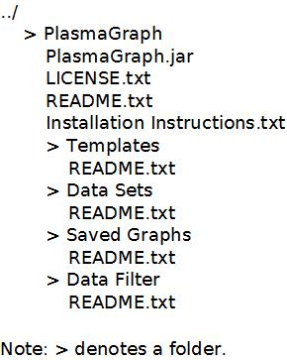
- Program Flow
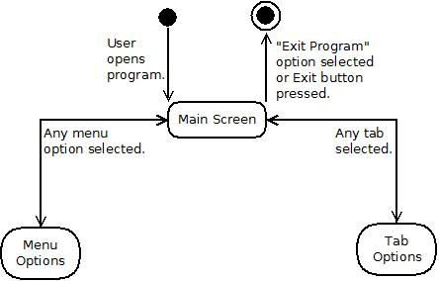

- Program Window States
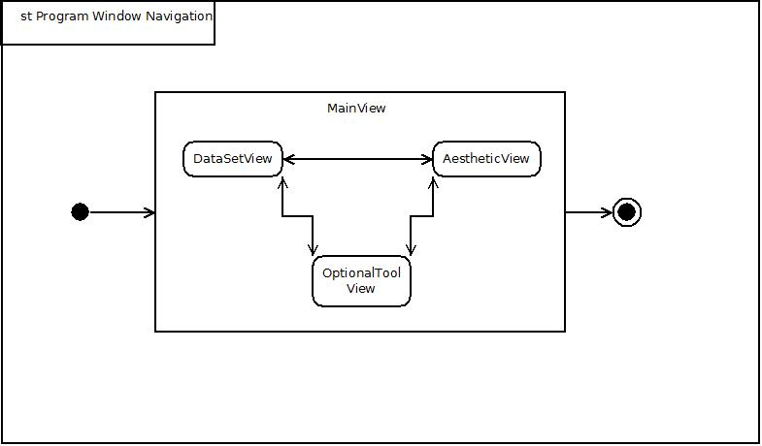
- View – Model Organizational Diagram
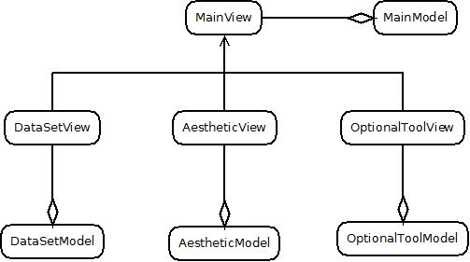

- Packages and Classes
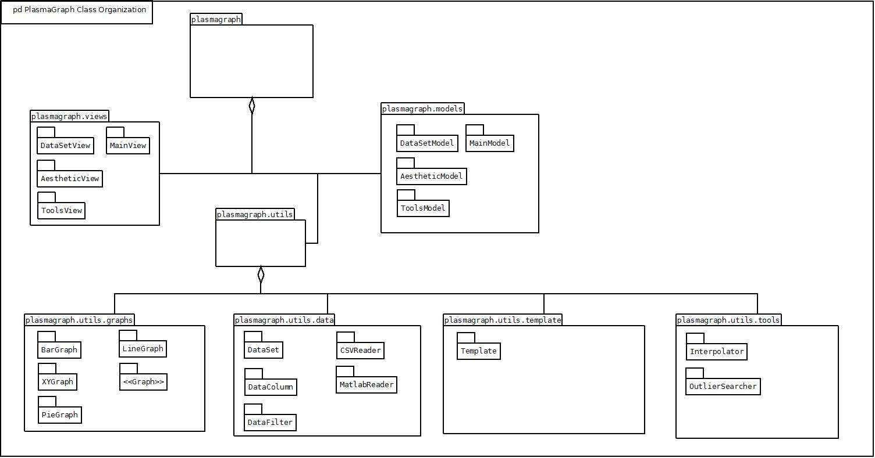

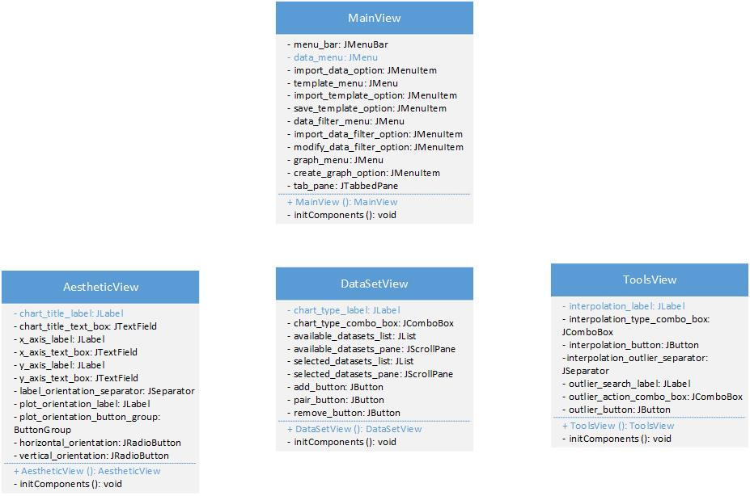
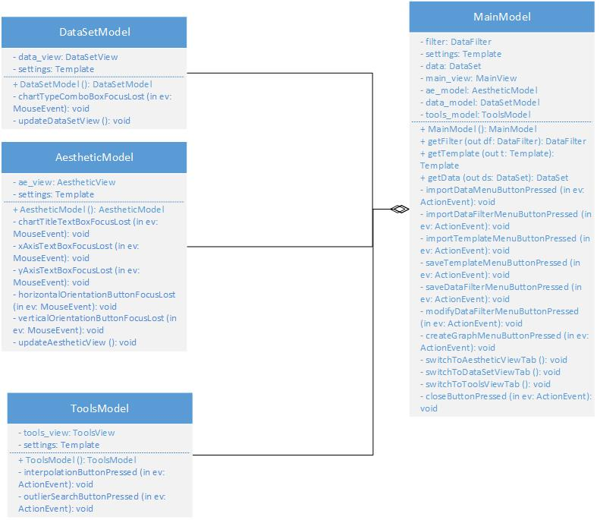

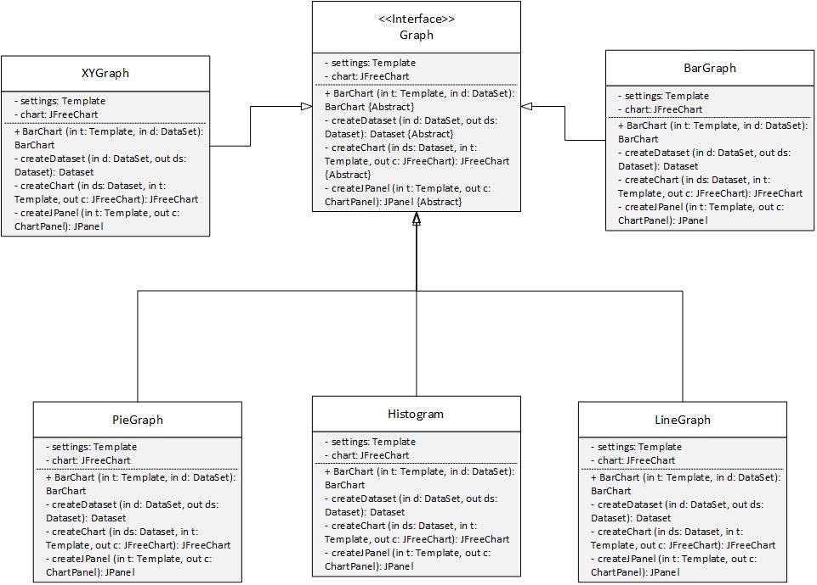
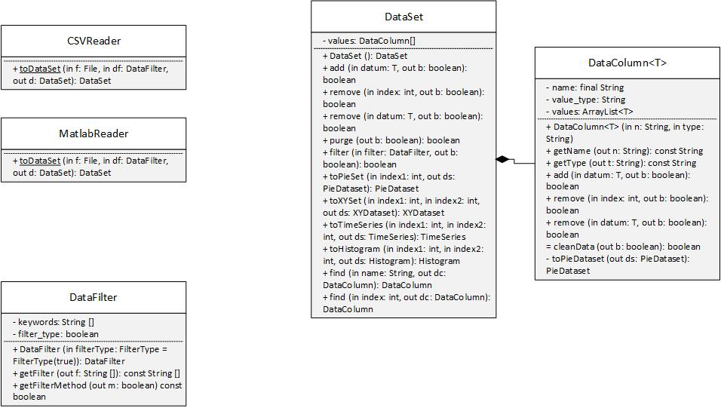
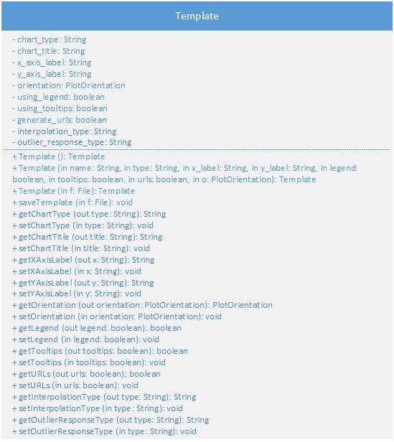
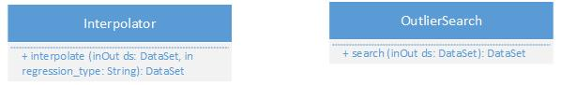

- Data Importing and Processing
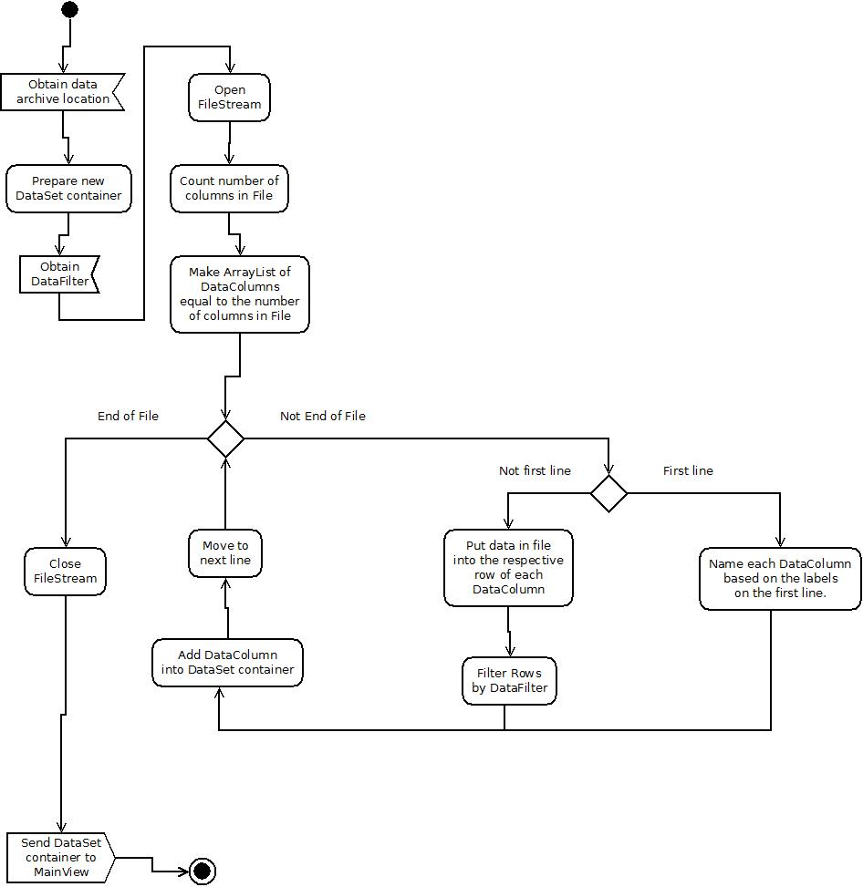
1. CSV File Importing

2. Matlab File Importing
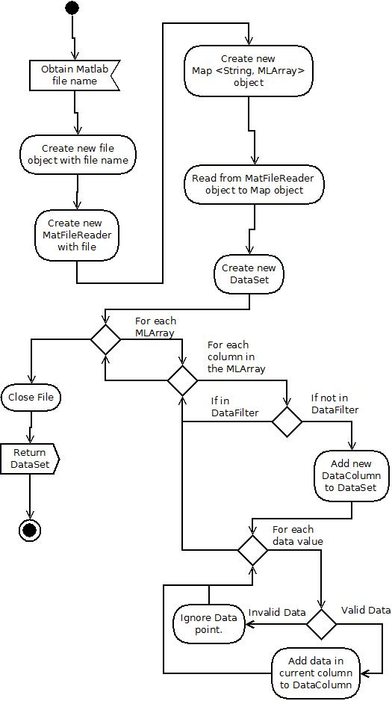

- Graph Creation (WIP; requires more diagrams.)

- Create Graph

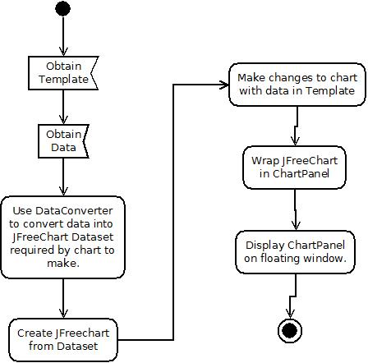

- Create “Dataset”s (JfreeChart data containers) from “DataSet”s (PlasmaGraph interim data containers)

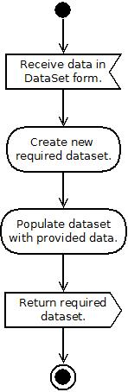

- DataSet to CategoryDataset

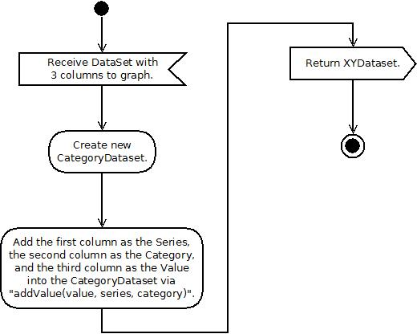

- DataSet to PieDataset
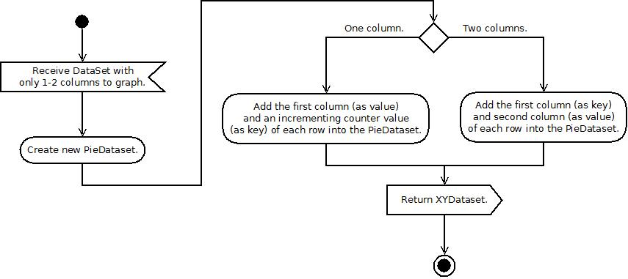
- DataSet to XYDataset

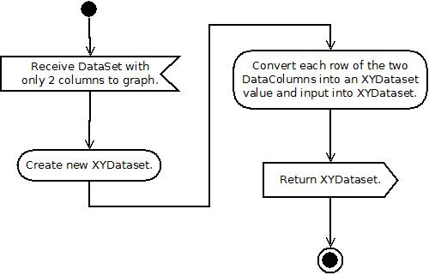
- Create Chart
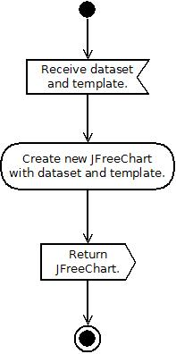

- Create JPanel Around Chart
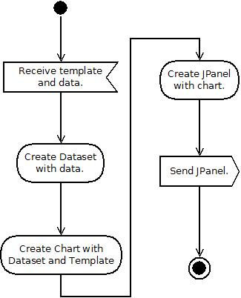

- Menu Functions
- Saving Templates and DataFilters
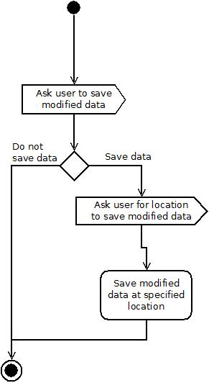
- Loading Data, Templates, and DataFilters
[N/A]

- Edit DataFilter
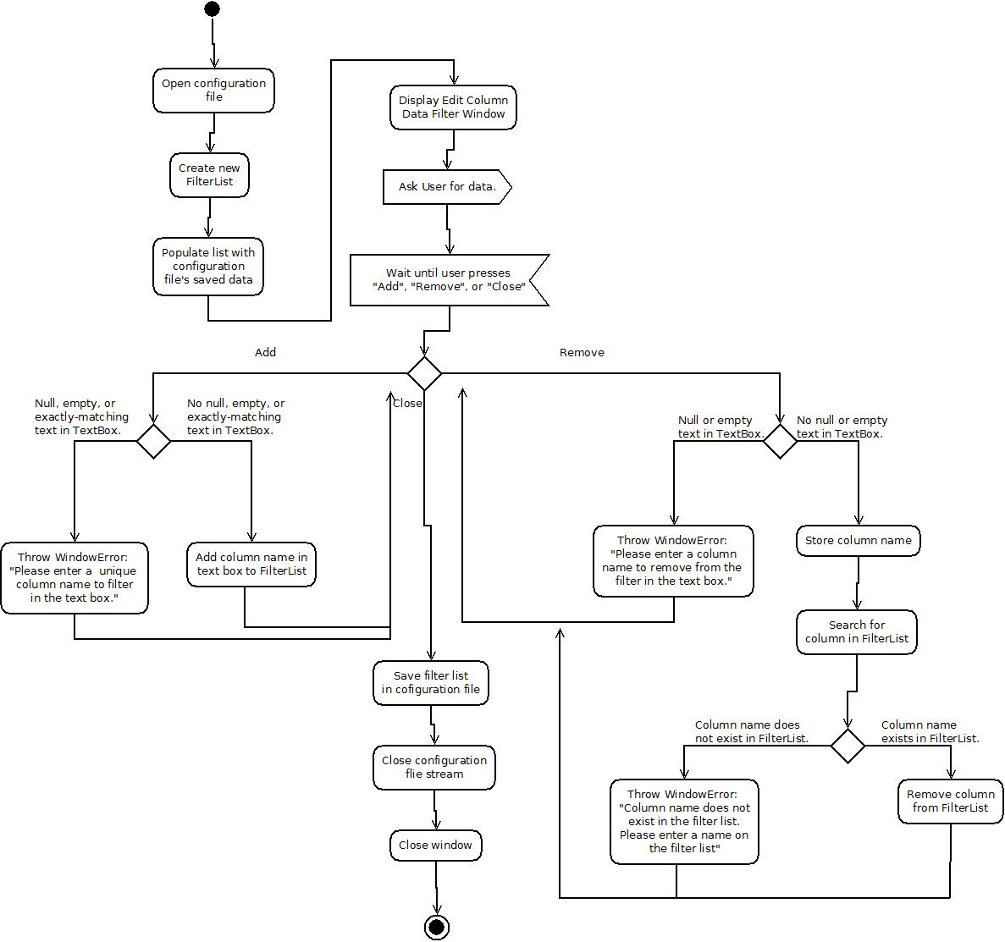

- Support Functions
- Interpolate Data
<Interpolation_Activity_Diagram.jpeg>
[Cut due to lack of space. Will be separated in two images.]
- Outlier Rejection
<Weak_Outlier_Rejection_Activity_Diagram.jpeg>
[Cut due to lack of space. Will be separated in two images.]
- Update Views from Templates
a. Update Aesthetic View from Template
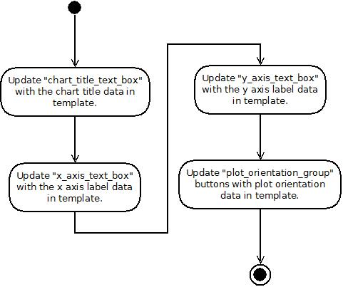

b. Update Data Set View from Template
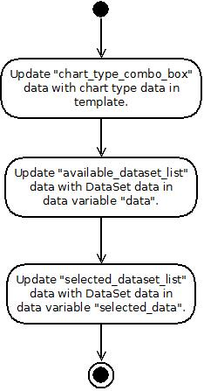
c. Update Tools View from Template
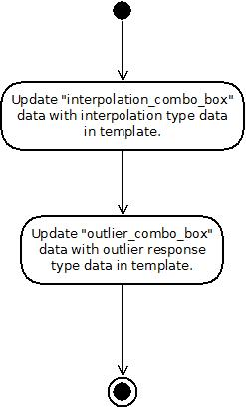
- Update Templates from View
a. Update Template from Aesthetic View
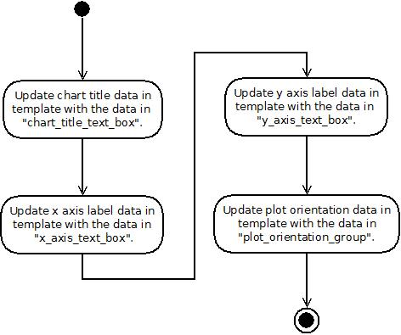
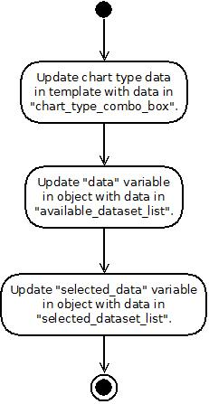
b. Update Template from Data Set View
c. Update Template from Tools View
